**Fire Extinguisher & Accessories**

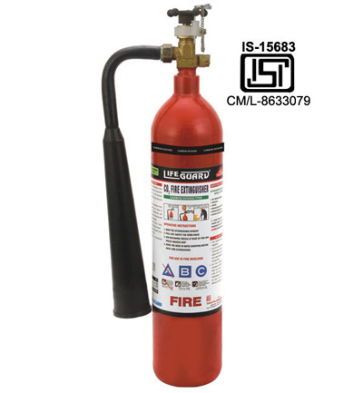 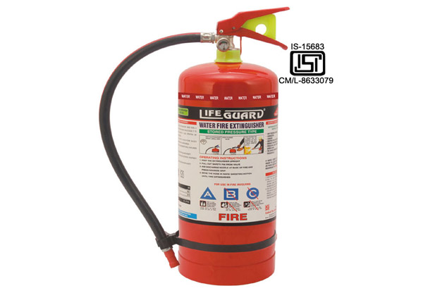

## CO2 Portable And Trolley Mounted Fire Extinguisher WATER PORTABLE FIRE EXTINGUISHER

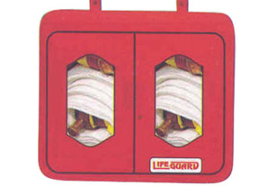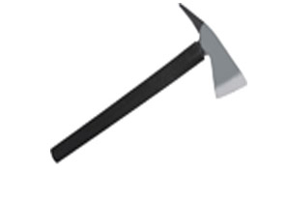

### Hose Box Fireman Axe

### http://capricornsafety.co.in/images/fire-extunguisher/5.jpghttp://capricornsafety.co.in/images/fire-extunguisher/6.jpghttp://capricornsafety.co.in/images/fire-extunguisher/7.jpg

### Landing Electric Siren Hooter

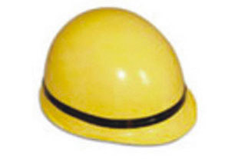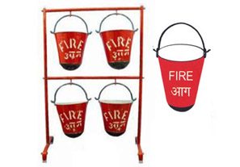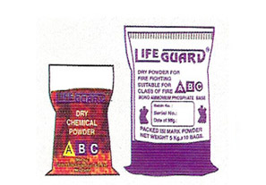

### Fireman helmet Fire Bucket Dry Powder

### 